**IELTS Writing task 1 Multiple Charts:**

The pie chart shows the main reasons why agricultural land becomes less productive. The table shows how these causes affected three regions of the world during the 1990s.

Summaries the information by selecting and reporting the main features, and make comparisons where relevant. Write at least 150 words.

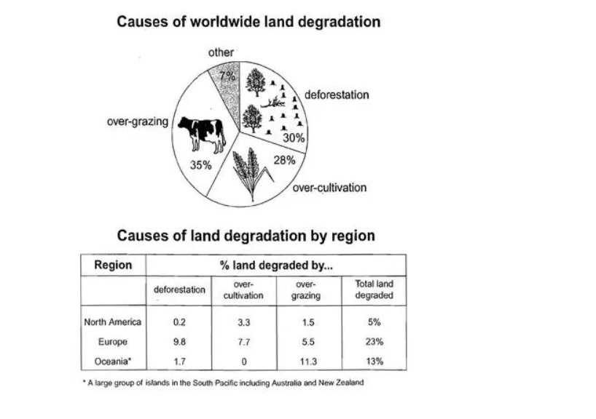Introduction: The pie chart illustrates the primary causes of global land degradation, while the table indicates the percentage of land affected by these causes in three regions of the world during the 1990s.

Overview 1: Overall, the pie chart shows over-grazing as the primary cause of land degradation worldwide, while the table clearly presents that Europe had the highest percentage of degraded land compared to other regions during the recorded period.

Overview 2: Overall, over-grazing, deforestation, and excessive cultivation are the primary causes of agricultural land degradation worldwide. However, the table indicates that Europe had a significantly higher proportion of degraded land compared to Oceania and North America.

Body 1: The pie chart indicates that over-grazing is the largest contributor, accounting for 35% of global degraded land. Deforestation and over-cultivation are also significant, representing 30% and 28% respectively, while the remaining percentage of degradation is due to other factors.

Body 2: According to the table, 23% of Europe’s agricultural land was affected by these causes, with deforestation contributing the highest at 9.8% to the loss of productivity. Oceania was the second most affected region, where over-grazing had the highest contribution at 11.8%, while the noteworthy factor was that Oceania did not over-cultivate the lands. Lastly, North America experienced the lowest level of productivity loss, with only 5% of its total agricultural land affected.

Complete Task:

The pie chart illustrates the primary causes of global land degradation, while the table indicates the percentage of land affected by these causes in three regions of the world during the 1990s.

Overall, the pie chart shows over-grazing as the primary cause of land degradation worldwide, while the table clearly presents that Europe had the highest percentage of degraded land compared to other regions during the recorded period.

The pie chart indicates that over-grazing is the largest contributor, accounting for 35% of global degraded land. Deforestation and over-cultivation are also significant, representing 30% and 28% respectively, while the remaining percentage of degradation is due to other factors.

According to the table, 23% of Europe’s agricultural land was affected by these causes, with deforestation contributing the highest at 9.8% to the loss of productivity. Oceania was the second most affected region, where over-grazing had the highest contribution at 11.8%, while the noteworthy factor was that Oceania did not over-cultivate the lands. Lastly, North America experienced the lowest level of productivity loss, with only 5% of its total agricultural land affected.